UNIVERSITY OF GHANA
DEPARTMENT OF STATISTICS AND ACTUARIAL SCIENCE
ASTA607 – APPLIED COMPUTATIONAL STATISTICS
END OF SEMESTER EXAMINATION (BLK 2)
INDEX NUMBER: 22425130
1ST MARCH, 2026

Question 1: Data Structure and Group Composition

(a) Describe the dataset using the one in package MASS
### Load the MASS package
library(MASS)

### Load the crabs dataset
data("crabs")

### Check dataset description
?crabs

Description:
The crabs data frame has 200 rows and 8 columns, describing 5 morphological measurements on 50 crabs each of two colour forms and both sexes, of the species Leptograpsus variegatus collected at Fremantle, W. Australia.

(b) Load the dataset and display its structure
### Load the crabs dataset
data("crabs")

### Display the crabs data structure
str(crabs)

Output:
'data.frame': 200 obs. of 8 variables:
$ sp : Factor w/ 2 levels "B","O": 1 1 1 1 1 1 1 1 1 1 ...
$ sex : Factor w/ 2 levels "F","M": 2 2 2 2 2 2 2 2 2 2 ...
$ index: int 1 2 3 4 5 6 7 8 9 10 ...
$ FL : num 8.1 8.8 9.2 9.6 9.8 10.8 11.1 11.6 11.8 11.8 ...
$ RW : num 6.7 7.7 7.8 7.9 8 9 9.9 9.1 9.6 10.5 ...
$ CL : num 16.1 18.1 19 20.1 20.3 23 23.8 24.5 24.2 25.2 ...
$ CW : num 19 20.8 22.4 23.1 23 26.5 27.1 28.4 27.8 29.3 ...
$ BD : num 7 7.4 7.7 8.2 8.2 9.8 9.8 10.4 9.7 10.3 ...

(c) Produce frequency tables for species and sex
## Frequency tables for species and sex
## Frequency table for species
table(crabs$sp)

## Frequency table for sex
table(crabs$sex)

Output:
Frequency table for species:
B O
100 100

F M
100 100

(d) Construct an appropriate bar or mosaic plot summarising the group composition
### Mosaic plot showing the distribution of sex and species
mosaicplot(~ sp + sex, data = crabs,
main = "Figure 1: Distribution of Species and Sex",
color = c("skyblue", "pink"),
xlab = "Species (Blue vs Orange)",
ylab = "Sex (Female vs Male)")

Output:
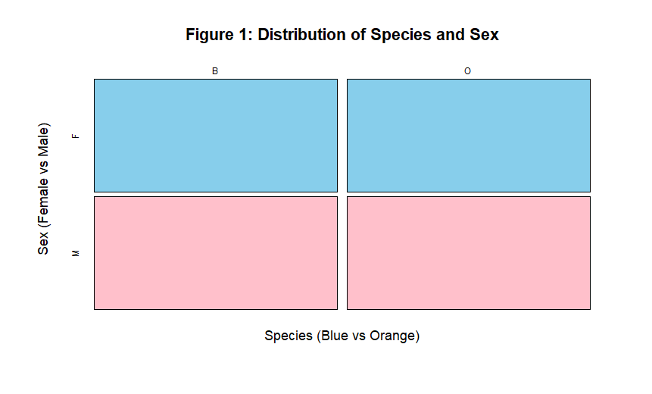

(e) Comment on whether the dataset is balanced across the four groups
Figure 1 result indicates that the data is balanced in the four groups with perfect proportion. Based on the findings, both species of crabs (B and O) have the same number of crabs and males and females represent equally in each species. Hence, the frequencies of all the four groups (B-F, B-M, O-F, O-M) are equal. This is an indication of an all balanced design where there are no group over- and under-representations.

Question 2: Distribution of the Body Depth

(a) Construct side-by-side boxplots of body depth (BD) for the four groups defined by species and sex
### 2.a) Combined grouping of species and sex
group <- interaction(crabs$sp, crabs$sex)

### Side-by-side boxplot of body depth (BD) by species and sex
boxplot(crabs$BD ~ group,
main = "Figure 2: Side-by-Side Boxplots of Body Depth (BD)",
xlab = "Species and Sex",
ylab = "Body Depth (BD)",
col = c("3", "6", "3", "6"))

Output:
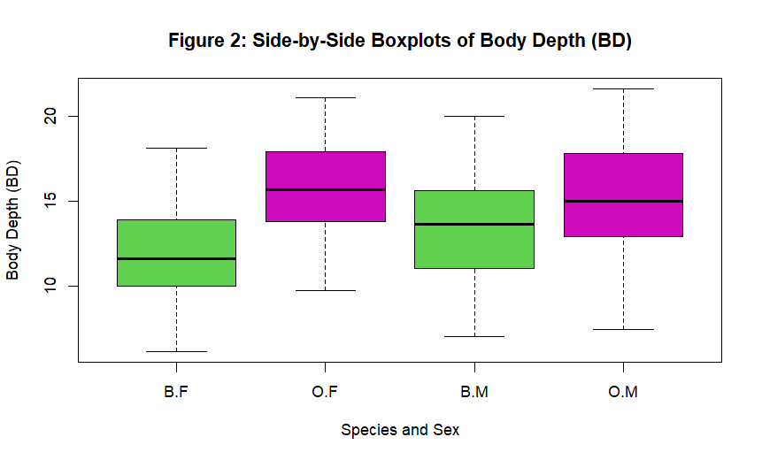

(b) Identify any outliers and compare the central tendency and variability between groups
According to the results in Figure 2 in (2.c), above, none of the groups has obvious outliers. Orange crabs are deeper bodied in terms of median body depth than Blue crabs with the largest median body depth belonging to Orange and the lowest median body depth belonging to Blue females. The variability is not much different between groups but the Orange groups are a bit more spread.

Question 3: Carapace Length Distribution by Species

(a) Produce histograms of carapace length (CL) for each species
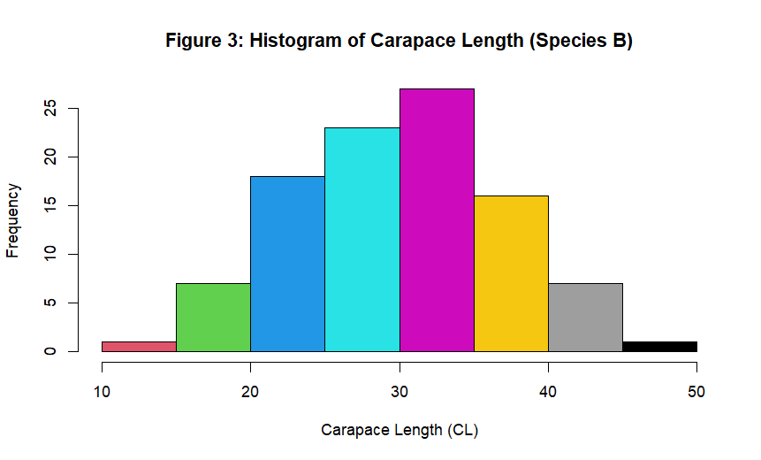

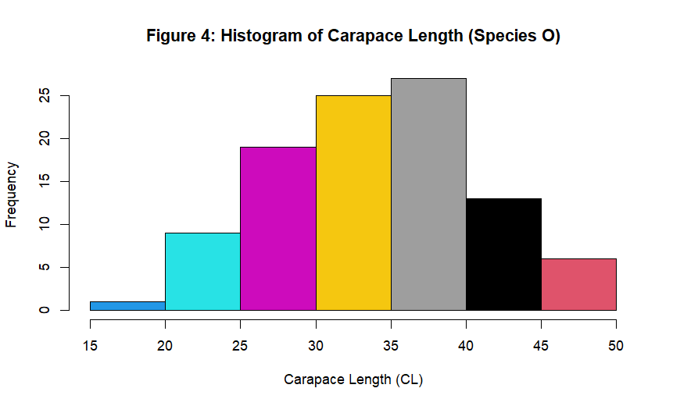

(b) Describe and compare the shapes of the distributions, commenting on skewness and modality.
According to Figure 3, Species B, the carapace length distribution is unimodal and approximately symmetric. There is no strong skewness and most of the values are concentrated in the middle (around 2535). The secondary peaks are not clear and have a single dominant mode.
Also, from Figure 4, the results show that the Carapace length (Species O) distribution is unimodal and nearly symmetric, but with slight skewness right as a result of a small number of large values. The bulk of observations are 30-40, which is the indicator of larger carapace lengths relative to Species B.

Question 4: Comparison of Mean Measurements

(a) Compute the mean of each morphological measurement (FL, RW, CL, CW, BD) by species and sex
### Creating a grouping variable
crabs$group <- interaction(crabs$sp, crabs$sex)

### Compute the means
means <- aggregate(cbind(FL, RW, CL, CW, BD) ~ group,
data = crabs,
mean)
means

Output:
group FL RW CL CW BD
1 B.F 13.270 12.138 28.102 32.624 11.816
2 O.F 17.594 14.836 34.618 39.036 15.632
3 B.M 14.842 11.718 32.014 36.810 13.350
4 O.M 16.626 12.262 33.688 37.188 15.324

(b) Construct a grouped bar chart to display these means.
### 4.b) Grouped bar chart displaying the means
barplot(mean_matrix_t,
beside = TRUE,
col = c("5", "6", "7", "8"),
legend.text = rownames(mean_matrix_t),
main = "Figure 5: Mean Morphological Measurements by Species and Sex",
ylab = "Mean Measurement Value")

Output:
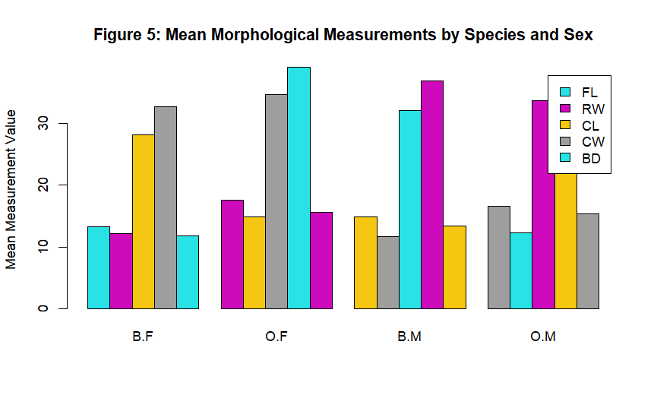

(c) Identify which measurement shows the greatest species difference and which shows the least sex variation.
### 4.c) Means by species only
### i. Species Difference (B vs O)
species_means <- aggregate(cbind(FL, RW, CL, CW, BD) ~ sp,
data = crabs,
mean)
species_means
abs(species_means[1,-1] - species_means[2,-1])

### ii. Sex Variation (F vs M)
sex_means <- aggregate(cbind(FL, RW, CL, CW, BD) ~ sex,
data = crabs,
mean)
sex_means
abs(sex_means[1,-1] - sex_means[2,-1])

Output:
Species Difference (B vs O):
FL RW CL CW BD
1 3.054 1.621 4.095 3.395 2.895

Sex Variation (F vs M):
FL RW CL CW BD
1 0.302 1.497 1.491 1.169 0.613

Question 5: Relationships Between Measurements
(a) Produce a scatterplot matrix (pair plot) of the five measurements
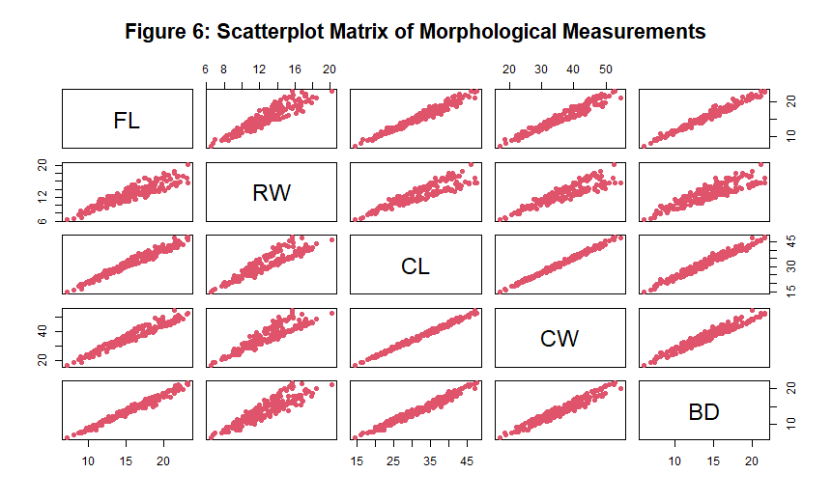

Question 6: Integrated Statistical Report
The crabs data set has 200 observations indicating five morphical measures of two species (B and O) and two sexes (F and M). The data is optimally balanced, having same representation in the species and sex groups, such that it has a completely balanced 2 x 2 design.
The results reveals that there is a greater species than sex difference in body depth. The median body depth of Orange crabs is typically greater than those of Blue crabs, and the range of variability between groups is also relatively comparable and there are no distinct outliers. Histograms of the carapace length suggest that both species are unimodal and roughly symmetric, although the Orange crabs are expected to have larger carapace length as a whole.
The analysis of the mean of groups shows that there is a definite difference between species in all of the five morphological measurements and the difference between species is usually greater than the difference between sexes. Specific variation in carapace length and carapace width is also quite pronounced among the species, and there are also measurements with a comparatively low difference between the sexes.
Finally, the correlation analysis and scatterplot matrix shows that there are positive linear relationships of high strengths between all the five morphological variables. Larger crabs are more likely to be larger in other dimensions, which implies that the measurements are a manifestation of a body-size structure. Altogether, the analysis shows that there are obvious species influences, modest sex and intense interconnections between morphological characteristics.

